J3ZZ Live Solo - Tech rider (english)
Last updated : 11.09.2023 - vibrotanica@j3zz.com

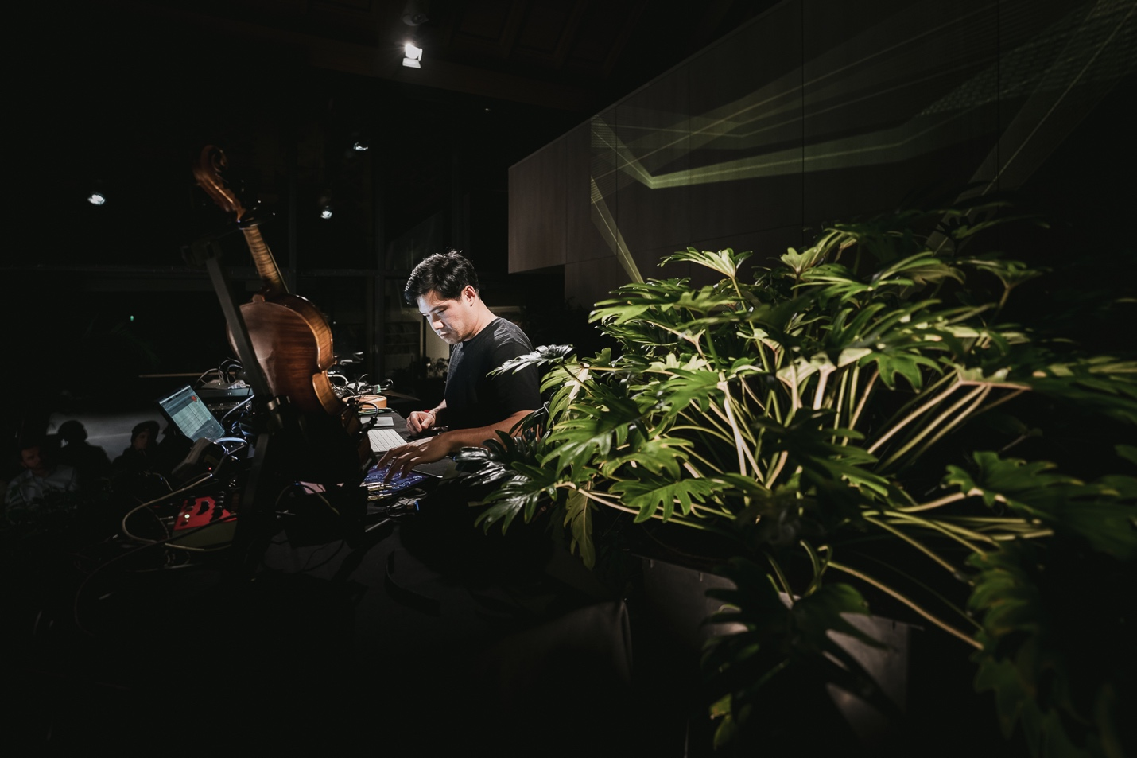
First of all, thank you for your interest in booking a show for J3ZZ Live Band. Below is a list of our technical requirements. It might sound a bit formal to you, this is not meant to cause any inconveniences on your behalf. We designed this rider for optimum effectiveness at the day of the show. If there are any questions or if you have trouble providing any of the below mentioned please get in touch with us before the day of the show and we will work out a solution.

Stage Set up

Jérôme Li-Thiao-Té - Main Artist, Mic speaker. (L) - Manager +33 (0)6 98 84 55 71.
Jérôme Ringana (on Réunion island) - Sound engineer FOH. (XL)
Aric Resnick (outside of Réunion island) - Sound engineer FOH. (XL)

Monitor System

Professional quality processed and bi-amplificated sound system.
*** * ALL MONITORS PROVIDED MUST BE OF THE SAME MODEL * ***
Two (2) Bi-Amped wedges
Two (2) Side Speaker monitors

Digital Setup

32 x 24 Digital Monitor console (Midas, Yamaha, Soundcraft….) and all the technical requirements for the proper functioning.

Analog Setup

EIGHT(8) Channels of 31 band graphic equalization (inserted not in cascade) Klark Teknik DN 360 or BSS DPR 966 Opal Drive Series
32 x 10 Monitor console (Midas, Yamaha, Soundcraft…)
ONE (1) Reverb type lexicon pcm 70
ONE (1) monitor engineer is needed for the monitor mix.

House mix (Front Of House)

Digital Setup

32 x 24 Digital FOH console (Midas, Yamaha, Soundcraft….) and all the technical requirements for the proper functioning, with USB capable recording.

Analog Setup

32 x 10 Monitor console (Midas, Yamaha, Soundcraft…) with minimum 2 Aux Sends. ONE (1) Equalizer Klark Teknik 1/3 octave - DN 360 (stereo)
ONE (1) Digital Reverb type Lexicon PCM 70
ONE (1) Digital Delay type Yamaha SPX 900
ONE (1) Digital multi effects
4 Channels Compressor / Gate type Drawner, dbx
10 Channels Compressor type DBX 160A
House technicians must be available from set-up through performance.

House Speaker System

House technicians must be available from set-up through performance.
The promoter will provide a high quality system, multiway active, this system must produce 100 DBA at average level at the mix position.
It will have a flat response from 20Hz to 20KHz.
This system shall be in perfect working order and totally free of noise or distortion.
P.A. SYSTEM - Meyer Sound, D&B, RCF, EAW, L Acoustics, JBL, Nexo…
Example: 1-500 people - 6000W, 500-800 people - 10.000W, 1000 people - 2000 people 15.000W.
The mixing desk will be placed between both sound systems and in 2/3 of the venue, NEVER under balconies and always in the same level as the audience.
If there is no area for the P.A desk, the PROMOTER will eliminate some seats in order to have this desk in a perfect position.

Microphones and arm stands

FOURTEEN (14) Direct Box RADIAL J48 (or Equivalent)
ONE (1) Shure BETA58 HF (Wireless UR Series)

Patch List (inputs)

CH | SOURCE | MIC / DI | STAND & ACCS | BACKLINE | COMMENTS
01 | SPKR-FL |  |  |  | FRONT-LEFT // XLR
02 | SPKR-FR |  |  |  | FRONT-RIGHT // XLR
03 | LOOPOUT-L | DI J48 // AR 133
04 | LOOPOUT-R | DI J48 // AR 133
05 | FXOUT-L | DI J48 // AR 133
06 | FXOUT-R | DI J48 // AR 133
07 | VIOLIN AKG C411 | DI J48 // AR 133
08 | MOOGMIX | DI J48 // AR 133
09 | IPAD-L |  |  |  | XLR
10 | IPAD-R |  |  |  | XLR
11 | BASSOUT |  |  |  | XLR
12 | SANSULA |  |  |  | XLR
13 | SNDCRD-03 | DI J48 // AR 133 |  |  | MIDDLE-RIGHT1
14 | SNDCRD-04 | DI J48 // AR 133 |  |  | MIDDLE-RIGHT2
15 | SNDCRD-05 | DI J48 // AR 133 |  |  | MIDDLE-RIGHT3
16 | SNDCRD-06 | DI J48 // AR 133 |  |  | HOUSE REAR-RIGHT
17 | SNDCRD-07 | DI J48 // AR 133 |  |  | HOUSE REAR-LEFT
18 | SNDCRD-08 | DI J48 // AR 133 |  |  | MIDDLE-LEFT3
19 | SNDCRD-09 | DI J48 // AR 133 |  |  | MIDDLE-LEFT2
20 | SNDCRD-10 | DI J48 // AR 133 |  |  | MIDDLE-LEFT1
21 | VOCAL DIRECT XLR | SHURE BETA 58 HF
22 | VIOLIN DPA | DPA V4099 | VIOLIN STAND

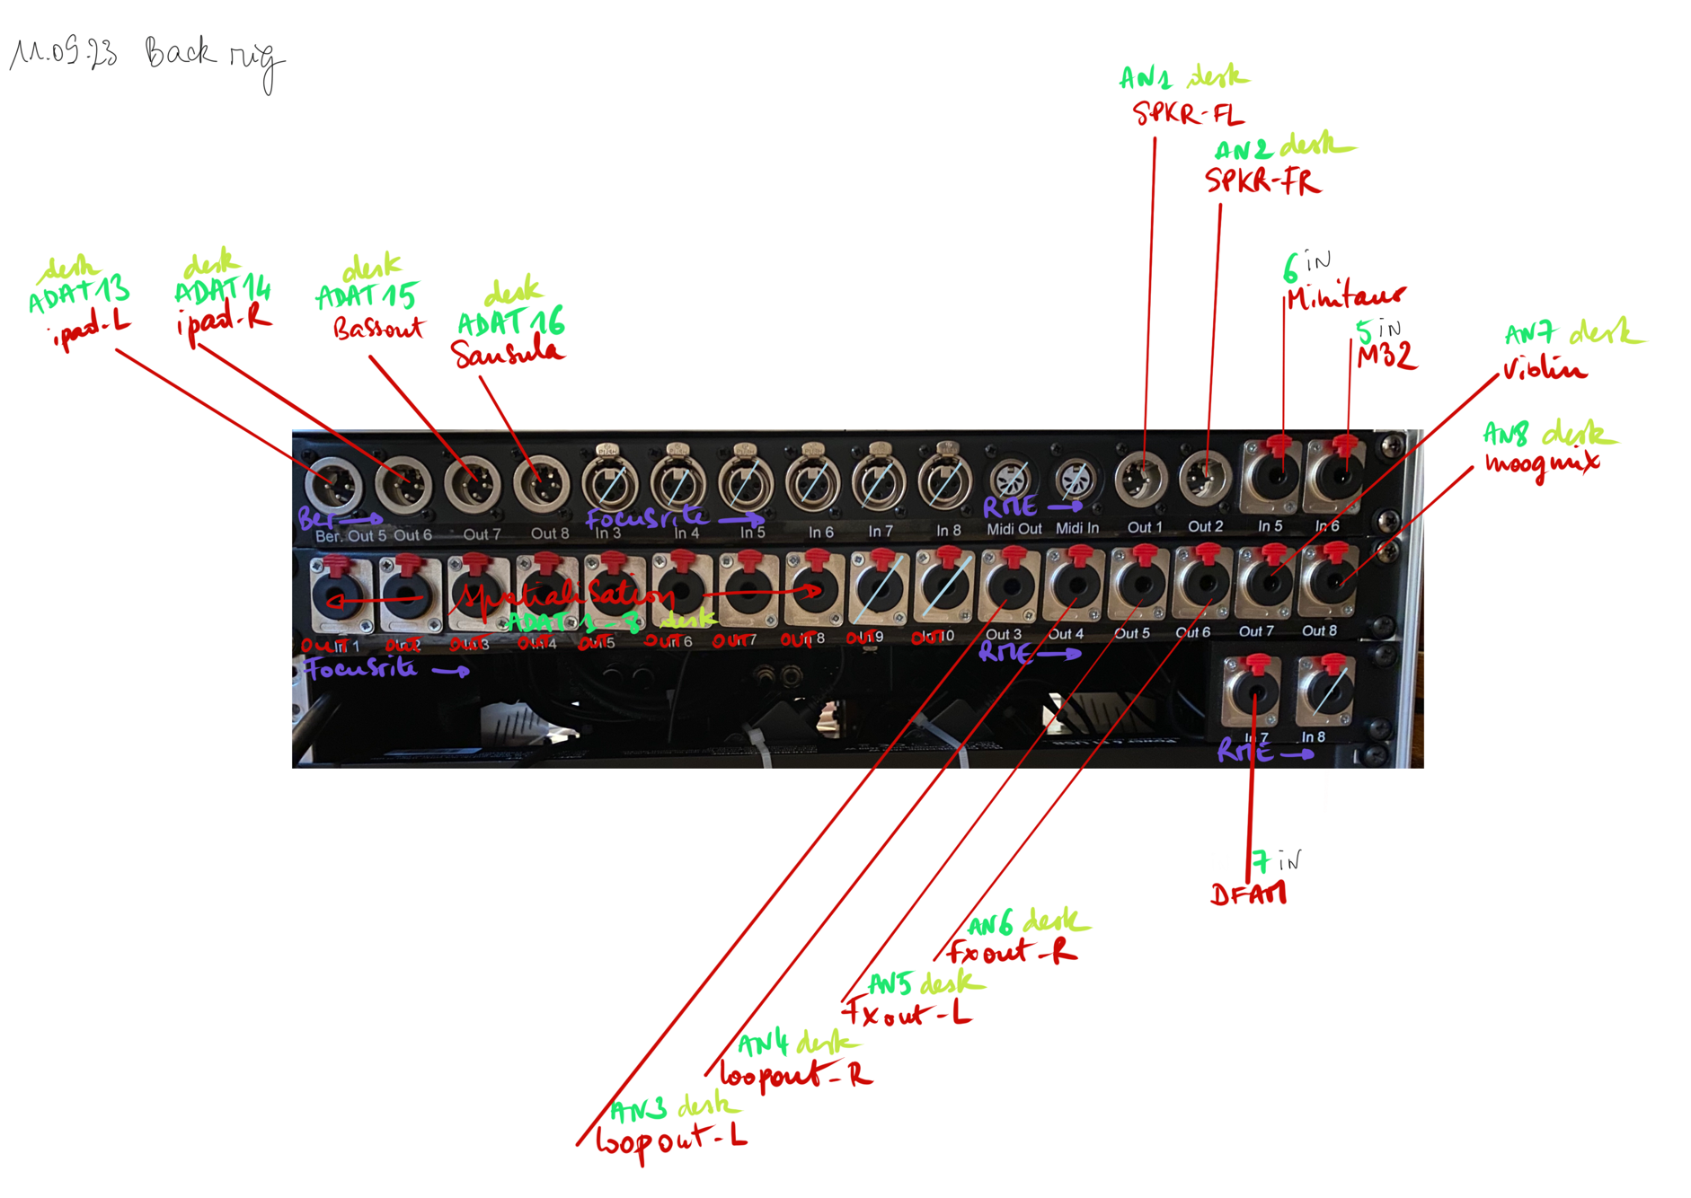
Only for J3ZZ
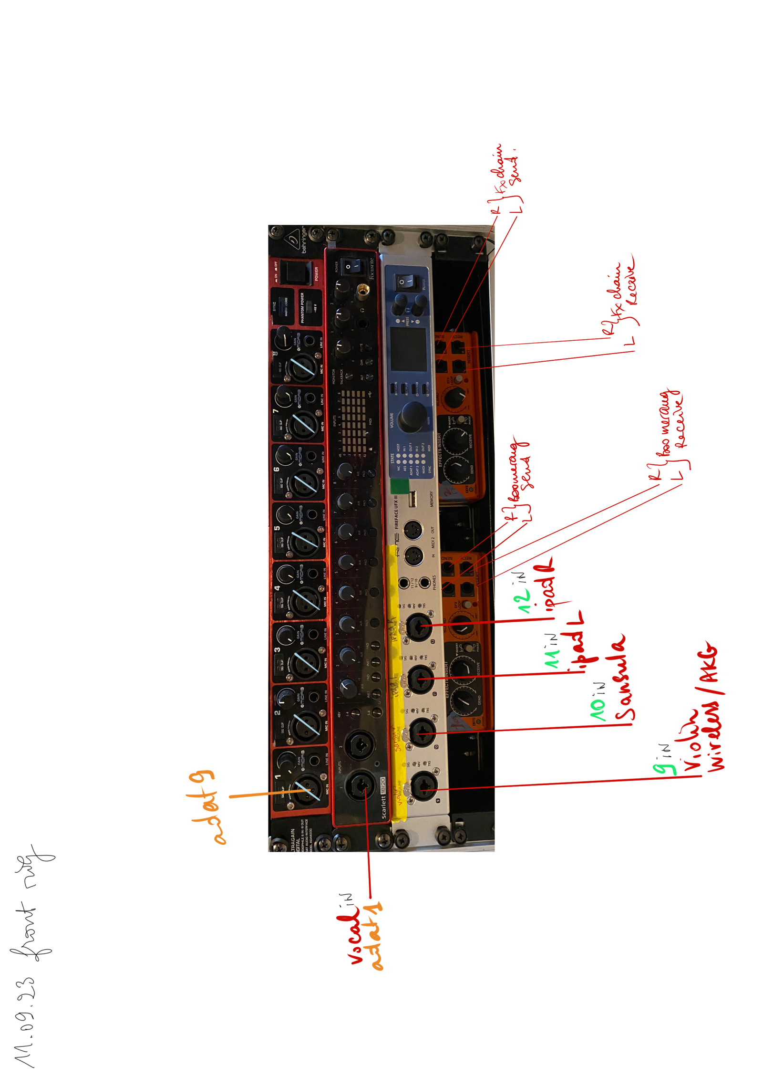
Only for J3ZZ

Stage plot

Power 16 amp independent circuit
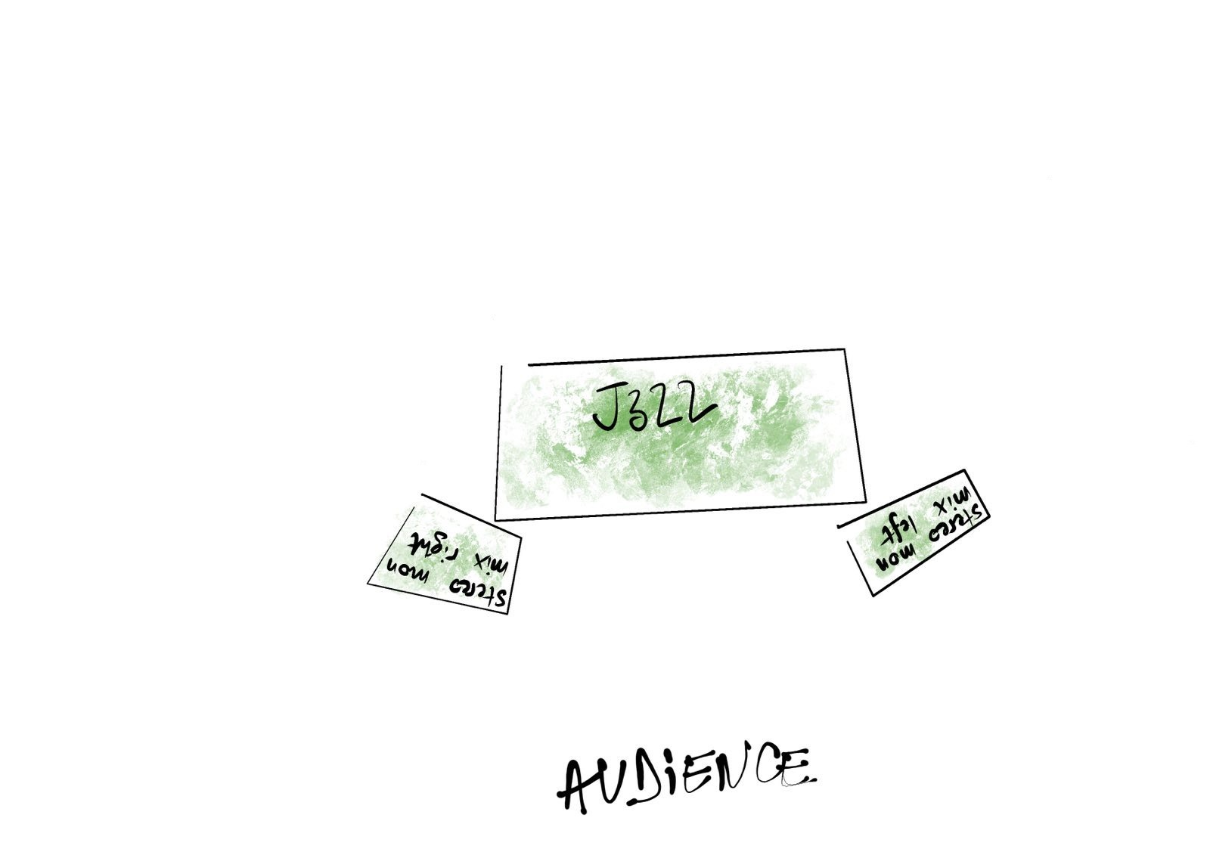

position | input |  | input | position
FRONT-LEFT | SPKR-FL XLR |  | SPKR-FR XLR | FRONT-RIGHT
MIDDLE-LEFT1 | SPKR-10 |  | SPKR-03 | MIDDLE-RIGHT1
MIDDLE-LEFT2 | SPKR-09 |  | SPKR-04 | MIDDLE-RIGHT2
MIDDLE-LEFT3 | SPKR-08 |  | SPKR-05 | MIDDLE-RIGHT3
HOUSE REAR-LEFT | SPKR-07 |  | SPKR-06 | HOUSE REAR-RIGHT

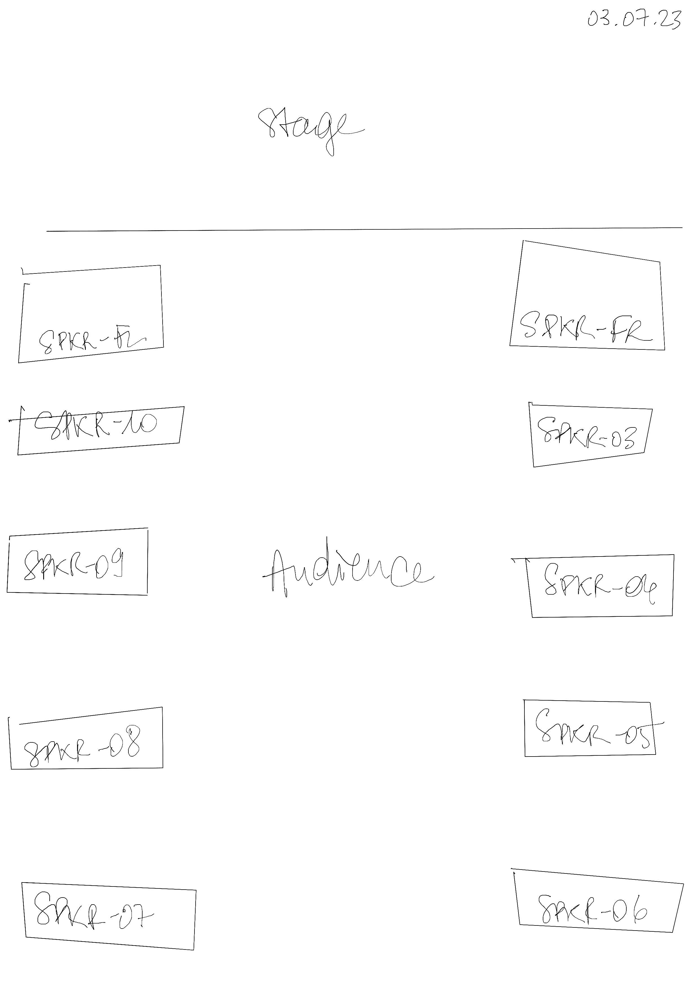

Outputs
01 | Main-L (Sub)
02 | Main-R (Sub)
03 | Speaker #1
04 | Speaker #2
05 | Speaker #3
06 | Speaker #4
07 | Speaker #5
08 | Speaker #6
09 | Speaker #7
10 | Speaker #8
11 | Stereo monitor –L J3ZZ
12 | Stereo monitor –R J3ZZ
13 | Stereo monitor –L Drums
14 | Stereo monitor –R Drums
15 | Stereo monitor –L Keys
16 | Stereo monitor –R Keys

Backline Requirements

TWO (2) BI AMPED MONITORS
TWO (2) SIDE STAGE SPEAKERS

Required lighting:
Stage lighting to be enough to cover the stage in a wash with colored filters and, or LED lighting colors tbd .
12 x moving head fixtures Robe, Clay Packy, Mac
Intelligent lighting console for Moving heads
Lighting operator for rehearsals and show

Required Projection:
12-20k lumen laser projector
HDMI connection at stage laptop
Projection screen to accommodate room size
Artist stage needs:
Stereo Monitors L-R at artist position on stage
ONE (1) STANDING HEIGHT 110 CM table with black covering 160-200 wide x 80cm deep
ONE (1) x 16-amp independent circuit at stage position
A sober English-speaking AV Technician who is experienced with the equipment and is to be available to assist for the duration of the artist’s visit to the venue.
All system control must be visible to our engineer if we are traveling with If not we will depend on the house staff for Sound, video, and lighting support.

Required green Plants :
The venue is required to provide four vivid plants with unwaxed leaves for the artist to set up the vibrotanica flat surface sensors (2.5 cm x 2.5 cm) on. The leaves should be completely natural and wide enough to accommodate the sensors. The plants should be large enough to be visible to the audience, with a minimum height of 1.5 meters.

The venue shall supply the following:
A high-quality audio system meeting the following requirements has to be set up and be in full working order 1 hour prior to sound check. A high-quality stereo three-way active PA system with Subs capable of providing a clear non-distorted sound with an even coverage of sound throughout the venue and capable of delivering a range between 20hz-20khz. Center fills were required, depending on the width of the stage.

Travel, Hotel, Dressing rooms and Catering

PURCHASER agrees to provide ARTIST’S REPRESENTATIVE with detailed directions to the place of performance. If ARTIST gives advance notice to PURCHASER that the ARTIST is arriving by air, PURCHASER shall, at his sole cost and expense, provide GROUND TRANSPORTATION for ARTIST’S entourage of four (4) people, plus luggage and instruments, etc. between airport, hotel, concert, venue, and return to airport upon departure.
If PURCHASER is providing HOTEL ACCOMMODATIONS, The rooms shall be available until the day after the performance with the ARTIST to comply with checkout times and hotel rules. Rooms shall be noise free, as well as completely dark, within close proximity to the venue, and CONTAIN BALCONIES and/or WINDOWS THAT OPEN.
PURCHASER shall provide two (2)+ comfortable and private DRESSING ROOMS. These rooms must be clean, dry, well-lit, heated or air-conditioned, shall contain at least chairs and shall be within easy access to clean and private lavatories which are supplied with soap, toilet tissue and plenty of clean towels (minimum 4). Towels shall be provided for ARTIST’S use in dressing rooms and on stage. A professional steamer (preferred) {or iron with ironing board} is required in band dressing room.
PURCHASER shall guarantee adequate SECURITY at all times to insure the safety of the ARTIST’S personal instruments and personal property from the beginning of load-in to completion of load-out. During soundcheck, performance, and after show, PURCHASER will have security backstage, on-stage, and at the mixing console. PURCHASER is held responsible for the personal belongings and for all equipment of the ARTIST.
HOSPITALITY: PURCHASER shall provide refreshments in quantities sufficient for four (4) persons, available from bands arrival until departure.
A good supply of Coffee with and without caffeine, Tea Water, and Soft drinks should be available at this time. mineral waters, beers,
dried fruits, sugar, lemon, and honey should be provided
spoons and an ashtray.
CHECK and remain available through company load out Menu Suggestions: Fish or Chicken with Rice and Vegetables, additional vegetable side dish, fresh bread and butter etc. *** * * No deep-fried or “fast” food please.**
PURCHASER shall also provide the name and address of a good quality restaurant for after the performance, restaurant should be at open between 11pm and midnight.

